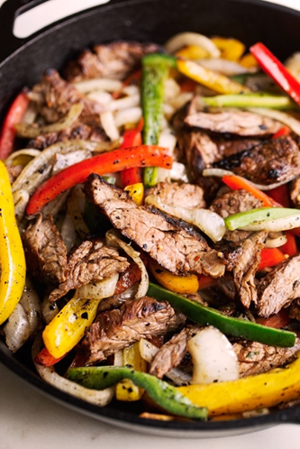Steak Fajitas

|  |
| --- |
| Ingredients With Measurements **Steak Marinade:**   * ⅓ cup lime juice * ¼ cup pineapple juice (no sugar added) * 2 tablespoon Worcestershire sauce * 3 tablespoon olive oil * 1 tablespoon minced garlic * 2 teaspoon ground cumin * 2 teaspoon chili powder * 1 teaspoon kosher salt * 1 teaspoon smoked paprika * ½ teaspoon black pepper * ½ teaspoon red pepper flakes * ¼ cup chopped cilantro   **Fajitas:**   * 1 ½ - 2 pounds skirt or flank steak * 1 tablespoon oil * 2 medium white onions, sliced * 1 large poblano, ribs and seeds removed then sliced * 2-3 bell peppers, thinly sliced |

|  |
| --- |
| Recipe Combine the ingredients for the marinade in a large shallow bowl. Give it a taste and check for seasonings, adjust to preference. Coat the steak with the marinade and let sit covered in the refrigerator for at least 2-4 hours and ideally overnight. Remove from the refrigerator 30 minute prior to cooking.  Set a large cast iron skillet or pan over high heat and let heat up for a couple of minutes. Add the steak to the pan and fry on each side for about 3-5 minutes or longer if you'd like it more done. Feel for desired firmness. The 3 minutes/side will yield a medium rare doneness. If the pan becomes too hot, reduce the heat to medium high. Remove the steak from the pan and allow to rest for several minutes tented with a piece of foil. Slice the meat against the grain into thin slices.  Add the remaining tablespoon of oil to the pan over high heat, add in the onions, poblano, and bell peppers. Let the veggies begin to sizzle and toss as necessary, cook for a total of 2-3 minutes or longer if you prefer them softer, season with a pinch of salt and pepper. **If your pan is small, cook the veggies in a few batches so they don't steam.**  Serve them in tortillas or on rice bowls topped with your favorite toppings! |

|  |  |  |  |  |  |  |  |  |  |  |  |  |  |  |  |  |  |
| --- | --- | --- | --- | --- | --- | --- | --- | --- | --- | --- | --- | --- | --- | --- | --- | --- | --- |
| |  |  |  | | --- | --- | --- | | Lime Juice | Pineapple Juice | Worcestershire Sauce | | Olive Oil | Garlic | Cumin | | Chili Powder | Salt | Pepper | | Paprika | Red Pepper Flakes | Cilantro | | Skirt Steak | Vegetable Oil | Onions | | Poblano Peppers | Bell Peppers |  Ingredients Without Measurements |